eBaja

Final Proposal

Team: 21F13
Octavio Duran
Brendon Jameson
Benjamin Plis
Abriana Romero
Jared Walker

2021-2022



Faculty Advisor: David Willy

DISCLAIMER
This report was prepared by students as part of a university course requirement. While considerable effort has been put into the project, it is not the work of licensed engineers and has not undergone the extensive verification that is common in the profession. The information, data, conclusions, and content of this report should not be relied on or utilized without thorough, independent testing and verification. University faculty members may have been associated with this project as advisors, sponsors, or course instructors, but as such they are not responsible for the accuracy of results or conclusions.

EXECUTIVE SUMMARY
This report will document the work completed by the eBaja mechanical engineering sub team during the Fall 2021 semester, as well as the team’s plans moving into the Spring 2022 semester. Working with an electrical engineering sub team headed by Venkata Yaramasu, the eBaja team’s goal is to restore and convert a previous year’s Baja vehicle to run off an electric powertrain.
After joining the project, the team met with our client, David Willy, to gain a preliminary understanding of the project and procure customer requirements. The team generated engineering requirements based on these customer requirements, and with further guidance from the client completed a house of quality diagram. Once this was completed, each team member conducted a literature review of specific topics pertaining to our project to learn as much as possible. Once that was completed, we found multiple different similar projects and products to benchmark our designs against. Before we began generating design concepts, we completed a functional decomposition consisting of a black box model and a functional model to improve the quality of our concepts. Once our team had generated several concepts, we used a Pugh chart and decision matrix to select a concept, creating estimate calculations to justify our decisions. During all this time, the team had been working on the vehicle in NAU’s machine shop to try and salvage as many original parts as possible and to determine what parts needed to be bought or manufactured in order to restore it to a rolling chassis.
The design our team has chosen at the end of the Fall 2021 semester is illustrated below. It includes a recreation of the original suspension, steering, and braking systems with some modifications, a motor and gearbox to give the vehicle rear wheel drive, a battery with a casing design that allows for easy battery swapping, and rear frame modifications that are still in the process of design.
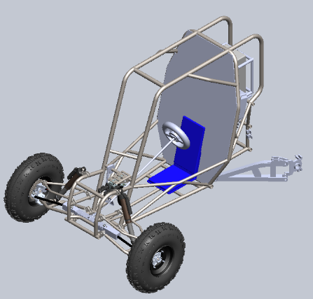
Figure 1: Full System Front view
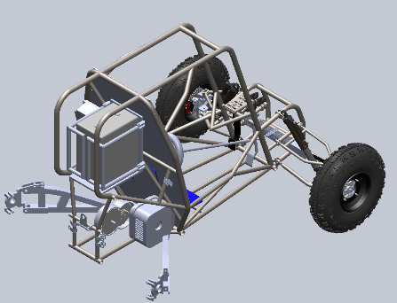
Figure 2: Full System Read View

TABLE OF CONTENTS
[Use Word to delete the following Table of Contents and insert a new TOC. Include front matter (except for the cover page), body of the report, and all appendices. The Table should include three levels of headings, e.g., down to 2.3.1, as illustrated below. Front matter should be in Roman numerals.]
Contents
DISCLAIMER 1
EXECUTIVE SUMMARY 3
TABLE OF CONTENTS 4
1. BACKGROUND 1
1.1. Introduction 1
1.2. Project Description 1
2. REQUIREMENTS 3
2.1. Customer Requirements (CRs) 3
2.2. Engineering Requirements (ERs) 3
2.3. Functional Decomposition 4
2.3.1. Black Box Model 4
2.3.2. Functional Model/Work-Process Diagram/Hierarchical Task Analysis 5
2.4. House of Quality (HoQ) 5
2.5. Standards, Codes, and Regulations 6
3. Testing Procedures (TPs) 2
3.1. Testing Procedure 1: Total Cost of Alterations 2
3.1.1. Testing Procedure 1: Objective 2
3.1.2. Testing Procedure 1: Resources Required 2
3.1.3. Testing Procedure 1: Schedule 2
3.2. Testing Procedure 2: Time to Swap Battery 2
3.2.1. Testing Procedure 2: Objective 2
3.2.2. Testing Procedure 2: Resources Required 2
3.2.3. Testing Procedure 2: Schedule 3
3.3. Testing Procedure 3: Vehicle Weight 3
3.3.1. Testing Procedure 3: Objective 3
3.3.2. Testing Procedure 3: Resources Required 4
3.3.3. Testing Procedure 3: Schedule 4
3.4. Testing Procedure 4: Firewall Electrical Resistance 4
3.4.1. Testing Procedure 4: Objective 4
3.4.2. Testing Procedure 4: Resources Required 4
3.4.3. Testing Procedure 4: Schedule 4
3.5. Testing Procedure 5: Brake Performance 4
3.5.1. Testing Procedure 5: Objective 4
3.5.2. Testing Procedure 5: Resources Required 5
3.5.3. Testing Procedure 5: Schedule 5
3.6. Testing Procedure 6: Part Factor of Safety 5
3.6.1. Testing Procedure 6: Objective 5
3.6.2. Testing Procedure 6: Resources Required 5
3.6.3. Testing Procedure 6: Schedule 5
4. Risk Analysis and Mitigation 6
4.1. Critical Failures 6
4.1.1. Potential Critical Failure 1: Gears 6
4.1.2. Potential Critical Failure 2: Motor Controller 6
4.1.3. Potential Critical Failure 3: Gearbox Casing 6
4.1.4. Potential Critical Failure 4: Gearbox Shaft 6
4.1.5. Potential Critical Failure 5: Frame 6
4.1.6. Potential Critical Failure 6: Fasteners 7
4.1.7. Potential Critical Failure 7: Motor 7
4.1.8. Potential Critical Failure 8: Spindles 7
4.1.9. Potential Critical Failure 9: Powertrain Wires 7
4.1.10. Potential Critical Failure 10: Gearbox to axle Shaft 7
4.2. Risks and Trade-offs Analysis 8
5. DESIGN SELECTED – First Semester 10
5.1. Design Description 10
5.1.1. Full System Design 10
5.1.2. Steering Subsystem 10
5.1.3. Powertrain Subsystem 11
5.1.4. Braking Subsystem 11
5.1.5. Mounting Subsystems 11
5.1.6. Suspension Subsystem 12
5.2. Implementation Plan 13
6. CONCLUSIONS 18
7. REFERENCES 19
8. APPENDICES 20
8.1. Appendix A: House of Quality 20
8.2. Appendix B: Gearbox Calculations 20
8.3. Appendix C: Braking System Calculations 22
8.4. Appendix D: Bill of Materials 23

BACKGROUND

Introduction
Team eBaja’s project goal is to mechanically restore and convert a previously designed Baja concept into an electric vehicle while working alongside an electrical engineering sub-team. Dr. David Willy and Dr. Venkata Yaramasu envision this project pioneering a multi-disciplinary effort to provide SAE with a working electric vehicle concept. The mechanical sub-team is responsible for restoring the vehicle mechanically; this means restoring the suspension, braking, and steering systems of the vehicle. The sponsors of this project benefit from the project’s completion in the sense of taking responsibility for pioneering a new area of competition in the United States SAE Baja competition. Also, this project will prove the capability of multi-disciplinary engineering projects to compete in a competitive setting. On a larger scale, this project advances the movement of transitioning vehicle development from Internal Combustion Engines (ICE) to electrical components. This movement is focused on minimizing environmental damage due to carbon emissions from the combustion of gasoline, which is ethically correct and provides a new challenge to automobile engineering.

Project Description
Following is the project description provided by the project sponsors:
“Every year, the student chapter of the Society of Automotive Engineers (SAE) at Northern Arizona University designs, builds, tests, and ultimately competes in the SAE Baja competition. When the competition is over, the vehicle is used for outreach, education, or even scrap material. To build on an existing project in the Mechanical Engineering Department and to leverage research taking place in the Electrical Engineering Department, it makes sense to use past vehicles that are still functioning to a point (at least a rolling chassis) to try something new.
To that end, the Mechanical and Electrical Engineering Departments would like to field a multidisciplinary team of ME and EE students to perform an electrical conversion on one of the past SAE vehicles. Specifically, the conversion is to be performed on the Baja vehicle shown in the image below.

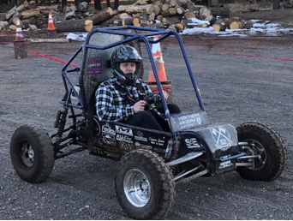
Figure 1: Team #52’s SAE Baja competition design

Since there is an existing vehicle, and power electronic equipment in the AMPERE Lab within the electrical engineering department, the next thing that would be required is space. The vehicle shown is on display across from room 118 in the engineering building (building 69) and will need to be moved to building 47A (the old surplus building) where there will be plenty of floor space for the team to work. From time to time the team will need to use the AMPERE Lab for their power electronic needs and the team will need to use the machine shop (building 98c) for mechanical fabrication needs.
The hope with this project is that these two sub-teams can demonstrate how electrical and mechanical teams can work together to produce a functioning product that can be showcased at SAE and NAU events. The long-term goal of this project is that this first year can be used as a first step to electric vehicle projects in the future at NAU.”

REQUIREMENTS
This section provides the customer requirements, engineering requirements and house of quality. The customer requirements come from the client, Dr. Willy, and the SAE Baja India rulebook. The engineering requirements come from the team after the customer requirements are generated. The house of quality is generated from the customer requirements and the engineering requirements.

Customer Requirements (CRs)
The customer requirements as shown in Table 1 are weighted from 1 being the low value to 7 being the high value. The three low weighted customer requirements are low weight, low cost, and battery accessibility. The lowest weighted customer requirement is low weight because it has an unrestricted weight requirement from the SAE Baja India rulebook. Low cost is the next incremented weight of 2 because the team is being granted $3000 from W.L. Gore & Associates and can fundraise if expenses are past the budget of $3000. The next incremented weight of 3 is battery accessibility because the team will design a battery casing in which the battery will be switched when it runs out of battery to a fully charged one. Strong components are weighted in the middle of 4 because the team will design or purchase strong components being the brakes, drive train mounting, gearbox, and suspensions so it can avoid failure when operating the Baja vehicle. The three high weighted customer requirements are fabricating missing and/or new parts, electrical safety, and structural safety. Fabricate missing and/or new parts is weighted high because at the beginning of the project, many parts were missing that were needed to get the vehicle operating which meant the team needed to fabricate major parts of the Baja vehicle. At this point of the project, more parts were found which means fewer parts need to be fabricated. The next incremented weight of 6 is electrical safety because there should not be any electrical parts such as wires being loose that could get caught onto the Baja vehicle while operating or electrical wires causing a shortage. The highest weighted customer need is structural safety because overall, the Baja vehicle should be safe when going through hills or if it happens to roll over, the driver should be uninjured and electrical components should not cause a fire.

Table 1: Customer Requirements
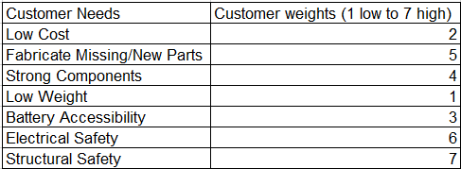

Engineering Requirements (ERs)
The engineering requirements were generated from the customer requirements with given parameters. After ranking each engineering requirement to the customer needs from 1 being least important, 3 somewhat important and 9 being important. With these rankings, they are multiplied to the weight of each customer requirement and added up. This determines the relative technical importance of each as shown in table 2. The top three important engineering requirements are total cost of alterations, factor of safety of parts and time to swap battery. The cost of alterations is the most important since our budget is $3000, and the team is aiming for a low cost of parts while delivering the customer needs such as strong components and safety overall. The factor of safety of parts is the second important requirement with aiming at 2.5 of parts of the Baja vehicle. The third important requirement is time to swap battery of no more than 30 seconds. Theoretically, if the Baja vehicle were competing, the battery would need to be swapped out to keep using the maximum power from the battery.

Table 2: Engineering Requirements
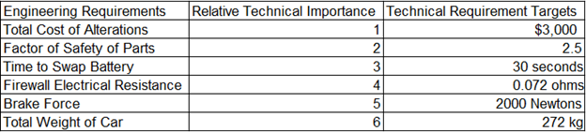

Functional Decomposition
In this section, we will describe the functional modeling our team conducted in order to gain a better understanding of the problem and improve the efficacy of our design concepts. First, the team completed a black box model, which helped us identify information, material, and energy flows that we may have otherwise missed. Informed by this model, we then created a functional decomposition model that outlines the steps our design must undertake to successfully operate while not biasing us on the methods the design achieves them.
Since the team’s preliminary report, no major changes were deemed necessary to either model. The reason for this is that our design functionality is quite well laid out, considering that our project consists of renovating an existing design and adding functionality that the EE sub team is providing us. A change in project direction would be required in order to justify more extensive model alterations.

Black Box Model
The black box model’s purpose is to help the team list and account for every flow into and out of the design, so that we do not neglect one. In our black box, batteries and drivers are material inputs and outputs, since both need to be present for the Baja to function but also are not consumed by the Baja. Unlike gas powered vehicles, our design has no material flows that are consumed or converted. Via the battery, electrical energy is input into the Baja where it is eventually converted into various energy forms that are output. Finally, the Baja is given information inputs via the driver, such as ignition, throttle, and brake commands and outputs information on its current state like charge level and braking state via some of the energy outputs like light and sound.
Since the team’s preliminary report, no changes have been made to the black box model since none of the design changes we have made changed the required input and output flows. What the model has done is help us refine the changes we’ve made to ensure each flow is accounted for.

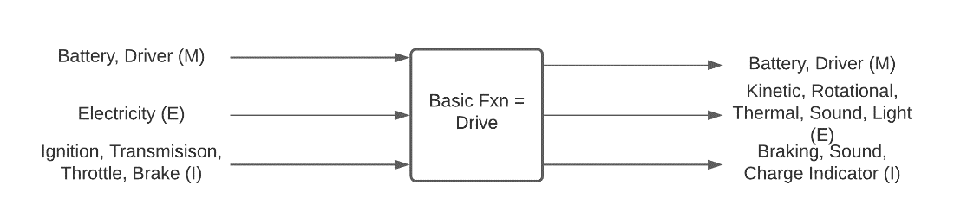
Figure 2: Black Box Model

Functional Model/Work-Process Diagram/Hierarchical Task Analysis
Similarly, to the black box model, the functional decomposition model helps the team understand the problem by graphically showing what actions the design must take to operate as intended. In order to avoid biasing our concept generation, all actions in the functional decomposition model do not imply a specific method of achieving them.
Minor alterations in wording were made to the functional decomposition model as seen in the team’s preliminary report to improve clarity. We made no changes to the model even after a thorough review because the model captures the design's functionality with sufficient detail as is.

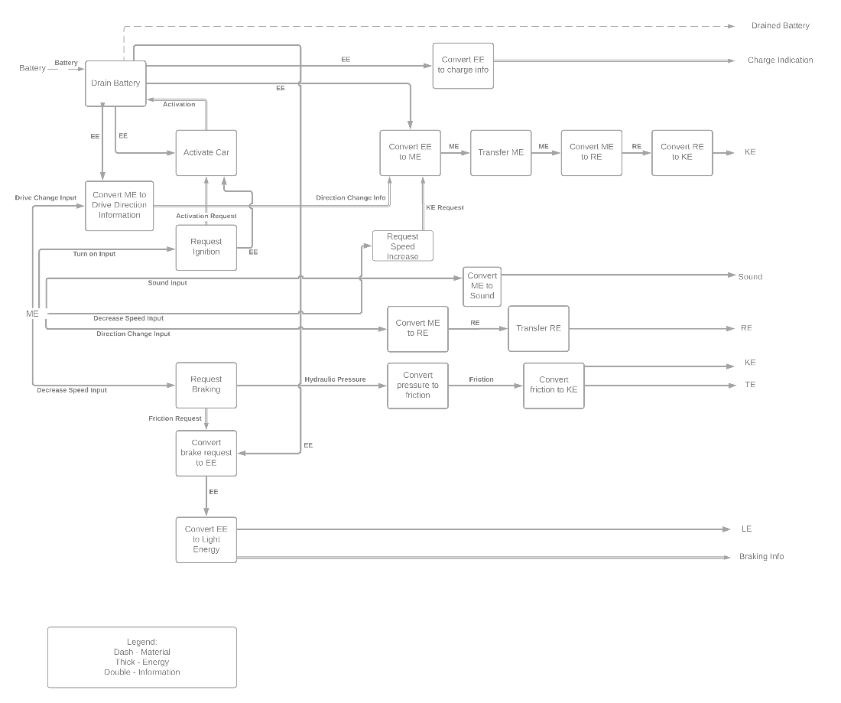
Figure 3: Functional Decomposition Model

House of Quality (HoQ)
The house of quality is generated from engineering requirements and customer requirements as shown in figure 1 in Appendix A. First in doing the House of Quality, the team needed to determine the customer requirements and engineering requirements. The team needed to weigh the customer requirements to figure out the important ones. The engineering requirements were then figured out with target values. The engineering requirements and customer requirements were compared in the body of the house of quality. Then the engineering requirements are compared to one another to see if there is any correlation which can be seen at the top of the house of quality. On the right side is benchmarking existing Baja vehicles that are evaluated with the customer requirements. Doing this house of quality has helped the team focus on the important customer needs being structural and electrical safety of the Baja vehicle when it is operating and ensuring to maintain at a $3000 budget with cost of alterations being the important engineering requirement.
At the bottom of the house of quality is testing procedures for each engineering requirement which can be seen in Appendix A. The testing procedure for alteration cost is figuring out the cost for the alterations while checking how much money is left from the budget. The testing procedure for factor of safety of parts is doing an FEA analysis of each part and determine the factor of safety of each part. The testing procedure for total weight of vehicle is by weighing the vehicle using a second-class lever. The testing procedure for brake force is to see if the brake force is enough to lock the wheels of the vehicle. The testing procedure for time to swap battery is timing in swapping the battery out of the vehicle with a separate battery. The testing procedure for firewall electrical resistance is measuring the electrical resistance with a multimeter.

Standards, Codes, and Regulations
One of the standards that is used for this project is the AGMA standards for the gearbox in the Baja vehicle. The AGMA standards have all equations and regulations in designing different types of gears. For this project specifically, spur gears are chosen for the gearbox. Using the AGMA standards helps design the spur gears with given motor specifications. The spur gears are used to make a gearbox which will then be connected to the rear axles.
The next standard that is used for this project is American Society of Mechanical Engineers. These standards have dimensioning and tolerancing for part drawings. These standards help in the project since some of the parts in the vehicle are to be manufactured and need part drawings with dimensions and tolerances. These help the manufacturer know the size of the part and how big the tolerance is for each section of the parts.
One regulation is the Baja Society of Automotive Engineers India which has a rulebook for the SAE Baja competition. This helps in the project because the vehicle must follow certain rules in order to compete. Since this eBaja vehicle will not be competing and will just be showcased, the client asked to follow the rules in this rulebook when rebuilding the Baja vehicle. As an example, one of the rules is having a firewall made of metal with a thickness of 0.02 inches.
Another standard is the ANSI (American National Standards Institute) ABMA-9-2015 American National Standard Load Ratings and Fatigue Life for Ball Bearings. This standard will help the team figure out dimensions, tolerances, and calculations for the correct type of bearing that can be manufactured by the team for the knuckles for the suspension work.
The next standard is ASME (American Society of Mechanical Engineers) B18.2.2-2015 Nuts for General Applications: Machine Screw Nuts, Hex, Square, Hex Flange, and Coupling Nuts. For this standard it will benefit the team to know the dimensions and best material to use for the fasteners on the Baja.
The last standard is AWS (American Welding Society) B02.1 Specification for Welding Procedure and Performance Qualification. This standard gives information about procedures that need to be followed when welding. Since the team is deciding to fix the rear framework for the Baja there is going to be some welding work that would be required to fix those design changes to accommodate for the battery's safety on the vehicle.

Table 3: Standards of Practice as Applied to this Project
Standard Number or Code | Title of Standard | How it applies to Project
AGMA | Fundamental Rating Factors and Calculation Methods for Involute Spur and Helical Gear Teeth | Helps in designing spur gears for a gearbox with given motor specifications.
ASME | Dimensioning and Tolerancing | Helps with dimensions and tolerances for part drawings
Baja SAE India | Baja Society of Automotive Engineers India Rulebook | Helps in restoring the Baja vehicle following SAE India rulebook
ANSI ABMA-9-2015 | American National Standard Load Ratings and Fatigue Life for Ball Bearings | Helps with dimensions, tolerances, and calculations for ball bearing for the knuckles.
ASME B18.2.2-2015 | Nuts for General Applications: Machine Screw Nuts, Hex, Square, Hex Flange, and Coupling Nuts | Helps establish dimensions for fasteners for the Baja vehicle.
AWS B02.1 | Specification for Welding Procedure and Performance Qualification | Helps with understanding the procedure for welding that can help with the framework for the ebaja.

Testing Procedures (TPs)
The following section details the testing procedures that will be carried out to verify the current iteration of the design and its subsystems fulfil Engineering and Customer requirements.

Testing Procedure 1: Total Cost of Alterations
Testing procedure 1 is calculating the total cost of alterations which is one of the engineering requirements. To do this, the team will use the budget form and average the cost of each component without exceeding the budget. This test has already been conducted by making a bill of materials and budget with recent purchases, but since new information has been given indicating more rear frame alterations, additional costs will be added.

Testing Procedure 1: Objective
This test will be conducted by using the budget form with recent expenditures and the bill of materials with average costs for parts. From there, the group will add cost in altering components in the Baja vehicle while keeping in check with the budget as necessary. This will help in evaluating the remaining budget while adding average expenditure for alterations.

Testing Procedure 1: Resources Required
The resources that are needed are the budget with recent purchases, bill of materials with average costs of each part, and a calculator to estimate total cost.

Testing Procedure 1: Schedule
This test will probably take 30 minutes and should be conducted around the first couple weeks of the spring semester or during winter break if there will be access to the machine shop during winter break. This would fit well into the spring semester if it were conducted the first weeks since the team will be adjusting to the ME 486C schedule along with team assignments.

Testing Procedure 2: Time to Swap Battery
Testing procedure 2 will measure the total time needed to complete a battery swap for the eBaja vehicle, which is an engineering requirement. The battery pack must be interchangeable with a new battery pack for this to happen. The team will time how long it would take to extract the battery from its casing with a stopwatch. The team will also observe the process of battery swapping to indicate any design adjustments to be made for quicker battery swapping. This test will be conducted after the team adjusts the rear frame of the ebaja.

Testing Procedure 2: Objective
To run this test, a stopwatch will measure the amount of time to successfully change the battery. The team will conduct multiple tests to reproduce multiple instances where the battery is swapped in 30 seconds or less. The team will use visual observation to indicate any necessary design changes to facilitate safe and easy battery swapping within 30 seconds, per engineering requirements.

Testing Procedure 2: Resources Required
In order to conduct this test, the team needs a stopwatch to record the time. This will take place wherever the Baja is currently parked. The ME sub team and EE sub team will need to be there to conduct visual observations to suggest improvements that will need to be made.

Testing Procedure 2: Schedule
This test will probably take about one to two hours to get accurate times and practice of swapping the battery packs. This testing will most likely occur mid spring semester depending on whether the machine shop will be available during winter break. If the machine shop is open, then this test may be done even sooner. The rear framework needs to be adjusted to the team's CAD (Computer Aided Design) framework design in order to conduct this test.

Testing Procedure 3: Vehicle Weight
Testing Procedure 3 will measure the total vehicle weight, which is one of our engineering requirements. To do this, we will weigh the car on a bathroom scale, using a beam to create a second-class lever to avoid maxing out the scale. This test can be done at any stage in the process but will be conducted primarily after adding particularly heavy components as well once the vehicle is fully completed.

Testing Procedure 3: Objective
To run this test, first we must prepare the measuring setup. First, place a bathroom scale on the ground. Then, create two towers of spacing objects of equal height, one on top of the scale and one 8 feet away and place an 8-foot beam on top of them. The towers are to be made tall enough that the vehicle does not touch the ground when balanced on top of the beam. Measure the scales output and then balance the vehicle on top of the beam. If needed, move the vehicle along the length of the beam to ensure it does not max out the scale and measure the distance between the vehicle’s center of gravity and the two end points of the beam. Take note of the scales output again. To calculate the weight of the car, we take the measured values and input them into the equation set out in Figure 6, where F₁ is the scale measurement before the vehicle was placed on the beam and F₂ is the scale measurement after the vehicle was placed on the beam.
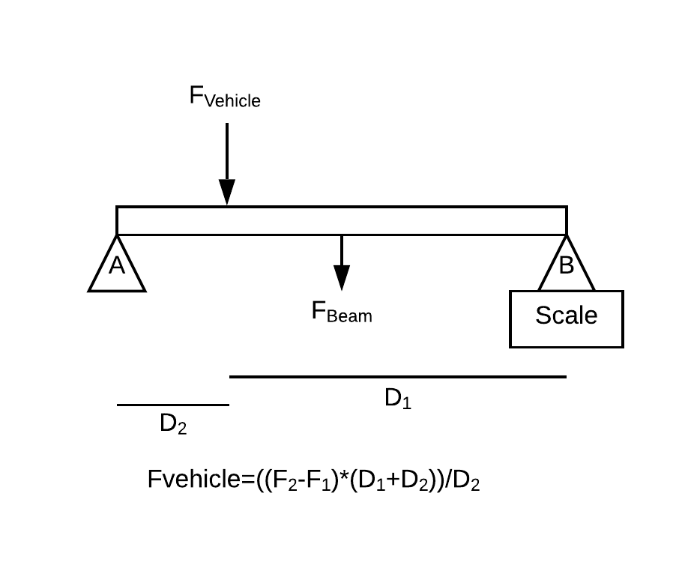
Figure 4: Vehicle Weight Measurement Setup

Testing Procedure 3: Resources Required
In order to conduct this test, we need an 8-foot long wooden or steel rectangular beam, a bathroom scale, several large spacing objects, such as wooden blocks, the vehicle, a large flat space with stable ground, and at least two people able to lift the vehicle.

Testing Procedure 3: Schedule
This test should take no more than 30 minutes to conduct, including setup, cleanup, and calculations. Because of the short amount of time to complete, this test can be conducted at any part of our second semester schedule and can be repeated to keep track of how the weight changes as we make changes and add subsystems to the vehicle. In addition, this test will be conducted after all alterations are made to verify the completed system meets our engineering requirement.

Testing Procedure 4: Firewall Electrical Resistance
Testing procedure 4 measures the electrical resistance of the firewall on the Baja vehicle. This is accomplished using a digital multimeter, which uses principles from Ohm’s Law to measure electrical resistance. The engineering requirement satisfied by this procedure is Firewall Electrical Resistance, namely. This procedure will take place after a final firewall design has been implemented within the design space.

Testing Procedure 4: Objective
A digital multimeter will be connected directly to the final firewall design and measure the resistance across both sides of the firewall. By placing the multimeter probes on either side of the firewall, the resistance across the firewall is measured. This is important information regarding the safety of the driver as well as the functionality of the vehicle. The resistance of the firewall needs to protect the user from electrical shock as well as restrict the conduction of all useable power to the powertrain system of the vehicle. A firewall with an appropriate electrical resistance satisfies these requirements.

Testing Procedure 4: Resources Required
The necessary resources for this procedure are a final firewall design implementation, a digital multimeter, and member(s) of the electrical engineering sub team. The purpose of the EE sub team member(s) is to advise the whole team on the design alterations that need/do not need to be made based on measurements taken.

Testing Procedure 4: Schedule
The test will last for approximately 20 minutes, accounting for retests and iterative measurements. The testing procedure will take place next semester after a final firewall design has been implemented. It is estimated that this will happen once all mechanical subsystems have been fully restored and tested for functionality and safety.

Testing Procedure 5: Brake Performance
The testing procedure for the brakes will be basic, the overall effect will be a test to see if the braking force is sufficient to lock the wheels of the vehicle. The ability of the system to lock the wheels is required in the Baja rules and as such the vehicle must be capable of doing this. Locking the wheels ensures that the vehicle will be able to stop on an incline in an off-road setting. This test will take place after the vehicle’s motor is installed and the braking system is installed.

Testing Procedure 5: Objective
The test’s objective is to ensure that the brakes are capable of effectively locking the vehicles wheels when the motor is running at top speed. The test itself will comprise of lifting the back wheel off the ground, running the vehicle up to its top speed and then applying the brakes. The result of the test is a simple yes or no result with the vehicle being either able to lock the wheels or not being able to. This test is checking whether the braking system can fulfill the Baja rules braking requirements and the ER brake force requirement.

Testing Procedure 5: Resources Required
This test will not require any additional resources outside of a functional vehicle and either a jack or a few cinder blocks to keep the back end of the vehicle off the ground.

Testing Procedure 5: Schedule
Before this test can be run the modifications to the frame must be completed, the suspension must be completed, the mounting points must be completed, and the motor, motor controller, and battery must be installed along with their associated wiring. The test will likely be conducted in the last stretch of the second semester as part of the final tests of the vehicle, likely around spring break. The test will not take more than 5 to 10 minutes in its entirety.

Testing Procedure 6: Part Factor of Safety
Testing Procedure 6 will ensure every part that the team manufactures will meet the 2.5 factor of safety engineering requirement. To do this, before manufacturing we will conduct an FEA analysis to determine the factor of safety of each part. This test will be done every time a part is sent to be manufactured.

Testing Procedure 6: Objective
To run this test, we will take the CAD file of the part to be made and open it in SOLIDWORKS. Using data on the maximum expected load the part needs to withstand, we will conduct an FEA analysis on the part within Solidworks. Based on the results, we will determine whether the part has a high enough factor of safety for us to use.

Testing Procedure 6: Resources Required
To complete this test, we need an accurate CAD file of the part in question, with accurate material property information, and access to a computer capable of running a Solidworks FEA analysis.

Testing Procedure 6: Schedule
This test will take no more than 20 minutes, and as such will be conducted at least once per manufactured part, and possibly more than once if the part initially fails the test. To run this test, an accurate CAD file of the part needs to be made.

Risk Analysis and Mitigation
The following section is an analysis of all potential failures that may occur during the operation of the vehicle and how they can be mitigated/eliminated.

Critical Failures

Potential Critical Failure 1: Gears
The spur gears in the gearbox could have a brittle fracture in damaging the connecting gears and have a failure in moving the vehicle. This can be caused by having a high cycling load either when doing testing or on the track if it were to compete. It can also be caused by operating the vehicle at high speeds or the gears are poorly manufactured. Before operating the vehicle, there would be an operation test in seeing the gears move and a sound inspection in making sure there are no crackling sounds or loose shrapnel moving around the gearbox. The recommended solution for the gears not having a fracture is increasing the size of the face width of gears.

Potential Critical Failure 2: Motor Controller
The motor controller could have technical difficulties which can cause the vehicle to not move or power on. The failure can be caused by the wiring not being connected right or the wires could be slit. Another way this failure can be caused is if the switches on the motor controller are broken causing the vehicle to not start. A recommended solution is to make sure the wiring is covered up and is placed where the wires can't be potentially slit. Making sure that the wiring stays clean, and the switches stay clean are another solution for keeping the motor controller working properly.

Potential Critical Failure 3: Gearbox Casing
The gearbox casing could have deformation or bending caused upon it due to heavy loading of parts or things around it causing the gearbox casing to not close properly to keep the gears safe. This could potentially get the gears dirty causing poor operation of the gears that then could negatively affect the drive train for the vehicle. To decrease the possibilities of deformation in the gearbox casing frequent checking on the mounting of the frame is still strong and that the casing bolts are correctly tightened to keep the gears safe. Another solution can be the material casing can be changed to a type of metal that isn't too heavy causing extra weight on the vehicle but has a higher yield strength to prevent the least amount of deformation.

Potential Critical Failure 4: Gearbox Shaft
The shaft of the gearbox could have deformation or bending based on the load of the gears and the casing. This could potentially have a loss of power transmission, an inconsistent operation of the gears and would have a high potential of wear in the shaft. This could be caused by being poorly manufactured or having a high load on the shaft. To test the shaft not deforming is having a visual inspection. To decrease the possibilities of deforming is choosing a different material for the shaft that ultimately has a higher yield strength.

Potential Critical Failure 5: Frame
The frame is a critical component that is responsible for ensuring the safety of the rider and the protection of, and ensured continuing operation of, the other components present in the design. The likely failure modes of the frame are that of bending of the frame, failure of the welds, or failure of the mounting points. All three of these would be caused by a high amount of force being applied to the frame during the vehicle's operation, such as the suspension bottoming out or if the vehicle lands after gaining altitude after a jump. To prevent these potential failures, an FEA (Finite Element Analysis) analysis of the modified frame will be conducted as well as having the welds inspected by someone knowledgeable in welding.

Potential Critical Failure 6: Fasteners
Fasteners are responsible for holding components and suspension members to the frame of the vehicle. Depending on what component the failed fastener was holding, the failure could be critical. The failure mode of the fasteners would commonly be shearing in a bolt. This would occur during an event like the vehicle's suspension bottoming out which would cause the transmission of force to the suspension arms and through those their mounting points on the frame. If a bolt, or multiple, were to fail on the mounting for a critical component like the motor then it would lead to damage to that component and others near it as well as making the vehicle inoperable. To prevent failures such as these from happening a factor of safety for the shear force present at these points will be used, this helps to mitigate a potentially lower shear force strength due to potential defects in the fasteners.

Potential Critical Failure 7: Motor
As the motor is a large, complicated component with moving parts, and is critical in the vehicle’s function, failures involving it are relatively likely and very serious. The most likely failure mode is a brittle fracture of either the output shaft or internal components. This failure could be caused by high torques produced by high acceleration or by impact. Such a failure would cause a loss of powered driving capability as well as the possibility of producing dangerous shrapnel. To mitigate these risks, we could encase the motor in an enclosure to protect both it and the surroundings from shrapnel.

Potential Critical Failure 8: Spindles
The potential failure mode of the spindles would be brittle fracture, causing sudden failure of the spindle and loss of turning in the wheel. This is caused by excessive force produced by unevenness of the road in conjunction with radial loads from the vehicle. This failure can be mitigated by inspecting the alignment of the tires as well as their rotation. A spindle with zero net strain will have even rotation of the tires as well as unaltered toe and camber angles with an unoriented steering wheel.

Potential Critical Failure 9: Powertrain Wires
The powertrain wiring is a major source of potential failure, as they are relatively fragile, can cause a loss of operation, and can create an electrical hazard. One potential cause of a wire cut is a wire being caught at a pinch point, such as the suspension system or steering rack. To mitigate this, we will securely mount wires to the frame such that they are situated away from potential pinch points, and in cases that it is not possible mount them in such a way that they cannot become stuck in moving parts.

Potential Critical Failure 10: Gearbox to axle Shaft
The gearbox-to-rear axle shaft (drive shaft) can exhibit bending or fatigue due to overbearing cyclic loading. Deformation or critical failure as a result of this overloading negatively affects the connection between the drive wheels and the gearbox, which transmits power from the motor to the wheels. This failure results in loss of power transmission to the rear wheels, which ultimately results in a significant loss of efficiency and overall operation. To mitigate this failure, visual and sound inspections focusing on the drive shaft will indicate any signs of deformation due to bending and/or load fatigue. Also, a simple operation test of the powertrain will allow the team to evaluate any potential modes of failure pertaining to the shaft.

Risks and Trade-offs Analysis
The first potential failure discussed previously was brittle fracturing of the gears located within the gearbox of the powertrain subsystem. The mitigation of this failure involves increasing the face width of the gears. While increasing area distribution of the loading stresses, thus reducing likelihood of failure, this method adds weight to the vehicle as a result. Though the significance of this added weight needs more thorough evaluation, this affects the “Total Weight” engineering requirement as listed within the House of Quality analysis. Additionally, adding weight to the vehicle affects braking and throttling calculations, which may in turn affect braking system selection as well as motor efficiency.
The potential failures identified for the motor controller are wiring damage or incorrect electrical set up. Vehicle operation is affected by this potential failure because if the controller for the motor fails, the motor will not provide power for the vehicle to drive. Mitigation for this type of failure involves operation testing to verify the function of the motor as well as placing and protecting wires within the vehicle in enclosed areas. This may affect firewall design as well as slight modifications to the frame of the vehicle, however these adjustments can be made without affecting major requirements of design. Similar considerations and discussions can be held for the powertrain wiring failures.
The next potential area for failure lies within the gearbox casing. Excessive weight of drivetrain components was discussed as the main source of potential loading and deformation of the gearbox. Any deformation of the gearbox casing directly affects gear and drivetrain efficiencies. The recommended mitigation method calls for using a lighter material with optimized yield strength characteristics. If such material is obtained, this would not affect other subsystems or requirements established for the design. However, similar effects of adding weight to the vehicle, as discussed with the gears, need to be considered if such material is unattainable; further analysis of this needs to be conducted if this design decision is further pursued.
Both drive shaft and gearbox shafts have potential failure modes of bending and loading fatigue. These types of failures result in loss of power transmission and increased wear of the gears and shafts. Recommended actions proposed for these failures involve improved material selection for materials with higher yield strengths. As with the gears and casing, this material selection process must account for additional weight variations between materials, which would affect vehicle performance and requirements for the design.
The main mode of failure identified within the frame is bending, with other potential failures being identified in the weldments and mounting points. For fastener components, the mode of failure predominant here is shearing, particularly within the bolts. Methods for mitigating these failures include using FEA within SOLIDWORKS to test for critical points along the frame, justified by factor of safety. Similar methods were proposed for the fasteners located on the frame. No recommended actions were proposed; however, this still allows for modifications to be made to the frame of the vehicle, which directly affects mounting designs taking place next semester.
Potential failures considered for the motor include brittle fracture of motor components, either internal or external. This causes failure of power supply from the motor, which negatively affects the entire operation of the vehicle. To mitigate this issue, a case over the motor to protect it and other vehicle systems from shrapnel in the case of critical failure. The motor selected for implementation within the drive train has been purchased previously by the electrical engineering team, specifically Dr. Yaramasu. This means that all design considerations have been made assuming this motor, meaning alternate motor models are not being considered for this design.
The spindles are the last potential failure consideration being discussed. Failures identified for this component are brittle fracture caused by vehicular radial loads and unevenness of the road. This affects steering and wheel connection to the frame of the vehicle. To mitigate this failure possibility, tire rotation and alignment tests need to be conducted, assessing the total strain of the spindle. This does not affect design considerations for other subsystems, nor does it affect the expected performance of the vehicle.

DESIGN SELECTED – First Semester
In this section, the team will detail the most recent design we have selected by subsystems as well as a tentative schedule for the spring 2022 semester that we believe will allow us to successfully implement our design.

Design Description

Full System Design
The full system design is going to be identical to the previous year’s Baja vehicle since the team is rebuilding the vehicle with parts that were found and parts that are going to be fabricated. This full system design is composed of four subsystems being steering, braking, mounting and suspension to the frame. The suspension for the front end consists of control arms with shocks and the rear end consists of trailing arms, shocks, and tie rods. The suspension connects from frame to tires and will work to absorb the impulse forces. The steering consists of a rack and pinion design that will then connect to the tie rods in pivoting the tires. The mounting subsystem consists of mounting the gearbox, motor, motor controller, and small components such as wires, headlights, etc. for the electrical components from the electrical capstone team. The brake subsystem consists of master cylinders, calipers, brake pads and brake lines which will ultimately slow down the vehicle. The powertrain subsystem consists of a battery, gearbox, a motor, and rear end axles which will speed up the vehicle. Some changes that will be considered for the future is altering the back frame to allow more space for components such as the motor, battery and gearbox.
Figure 5: Full System Front view
Figure 6: Full System Rear View

Steering Subsystem
The steering subsystem consists of a rack and pinion design that controls the direction of travel. The steering wheel and column connect to the rack and pinion system which allows rotation in the wheels. The team is looking up steering kits online and have found a couple with a full steering kit with complete end to end steering system just without a steering column and steering wheel which can be fabricated or found on another online source. Since these kits can be quite expensive, the team can hopefully find a cheaper one or fabricate some parts and buy the spare parts that will be needed.

Powertrain Subsystem
The powertrain subsystem consists of having a battery, motor, gearbox, and rear end axles. The motor and battery are given from the electrical team and will supply power to the vehicle. With the given motor and its specifications, it will be connected to a gearbox. At the end of the gearbox, it will be connected to the rear end axles. Since the electrical team does not know the speed of the motor yet, there was an average speed that was found online with spec sheets for the specific motor that was being used. With this, a gearbox calculation was conducted in finding the output speed and torque of the gearbox. These calculations can be seen in Appendix B showing the output speed being 521.98 RPM which is 34 mph, and the output torque is 2105 in-lb. These calculations are not final since the input is just an average speed but once the speed of the motor is finalized, the calculations on speed and torque would change.

Braking Subsystem
The braking system consists of a master cylinder actuated by a braking pedal, which pressurizes brake fluid in brake lines. These brake lines branch out to each wheel and the pressure in them causes the attached brake calipers to clamp the brake pads down on the rotor. This creates a large amount of friction that slows the tires. The calculations were performed in excel with the calculations being based on similar calculations performed in a paper from the International Journal of Engineering Research and Technology [7]. The purpose of these calculations is to verify that our current braking components will be sufficient to stop the vehicle safely. With the current master cylinder and brake calipers the calculations say that a brake caliper with a diameter of 1.05” will be sufficient which means that the team 1.25” GP200 wildwood calipers will be sufficient for stopping the vehicle.

Mounting Subsystems
This subsystem consists of the mounting that the components provided by the electrical sub team will need to connect to the vehicle. The first component from the electrical sub team is the motor, which requires no mounting alterations as it is already in a protective shell and already has points to be bolted directly to the frame. The next component that requires mounting is the battery. The battery mounting consists of a sheet metal base and one sheet metal wall. Two arms on each side of the battery made of metal pipe are affixed to the wall and can swing open and close to allow easy battery replacement while still containing the battery. The open-air design is a requirement from the electrical sub team since the battery needs air cooling to operate safely, and the ease of replacement both because battery swap time is one of our engineering requirements and the battery is of considerable weight.
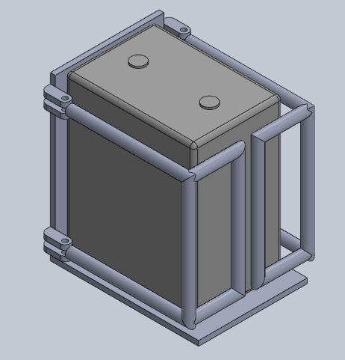
Figure 7: Battery Casing CAD
The final electrical component the mechanical sub team is currently working to mount is the motor controller. The motor controller already has mounting points on it, but to better protect it we will create a plastic cover that shields it from debris.

Figure 8: Motor Controller Cover

Suspension Subsystem
Our suspension subsystem design is identical to the suspension design used by the original team that designed and built Baja 44. As such, our work on the suspension subsystem has and will continue to be effectively rebuilding what was originally there. The rear suspension consists of a front trailing arm and two rear linkages to connect the rear knuckle to the frame while limiting its degrees of freedom. A shock also connects to the frame and knuckle to allow the suspension to absorb impacts. The front suspension subsystem consists of two suspension arms that connect to the front knuckle and a shock connected to the frame and the bottom suspension arm. Both kinds of knuckles provide an interface to mount the wheels onto the vehicle, and the front knuckle provides additional attachment points for the steering and braking systems.
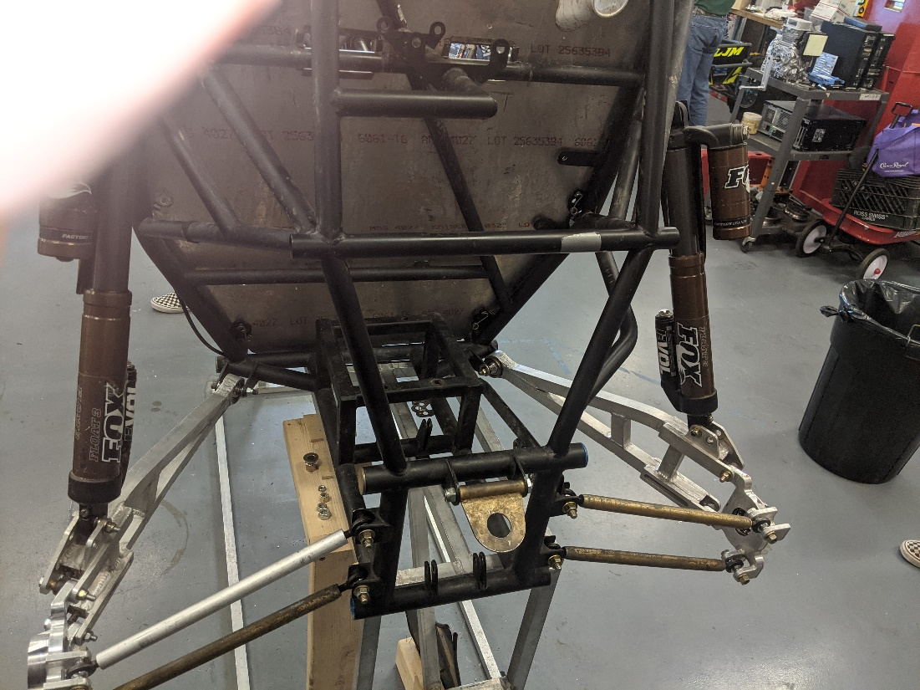
Figure 9: Current Rear Suspension Subsystem

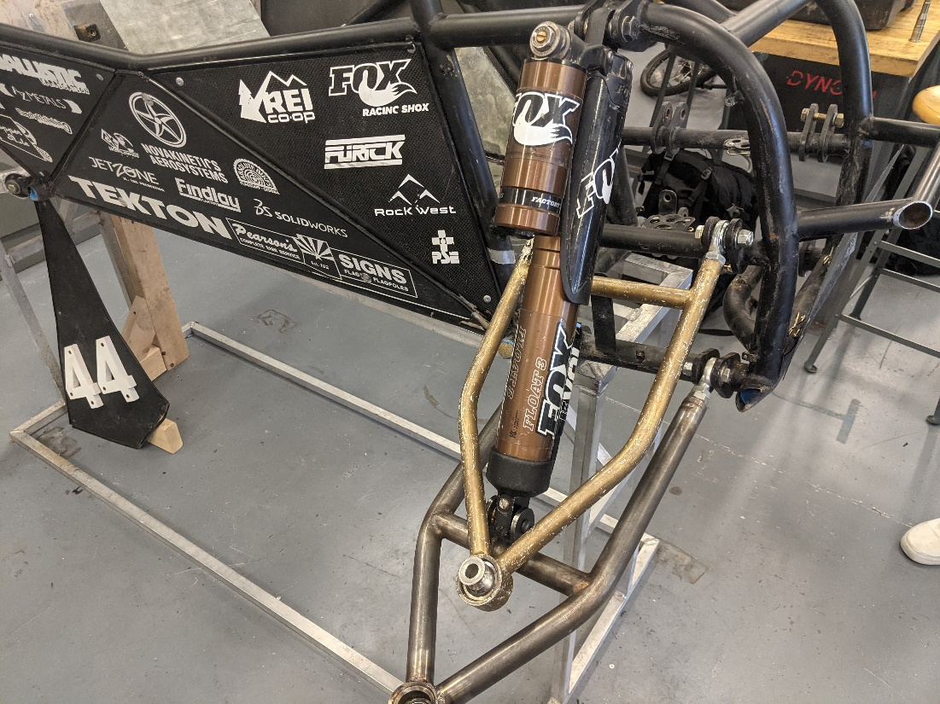
Figure 10: Current Front Suspension Subsystem

Implementation Plan
The implementation of the design will involve making physical alterations and additions to the vehicle. This will include the fabrication and restoration of previously damaged, missing, or newly required parts, the creation of new mounting points on the frame for the electrical components and the alteration of the frame to dimensionally accommodate the electrical components.

The processes that must be performed to complete the design are as follows:

- Alterations to the frame must be made to accommodate the new electrical components. The alterations to the frame will be made in the machine shop (building 98c) using the shop’s welding resources. Due to the lack of welding training among team members the aid of someone skilled in welding will need to be obtained. The information required to carry out this task will be a CAD model detailing the finished result of the alterations and a drawing of the altered frame to be followed during the alteration process. This will require a stock of 4130 chromoly 1” pipe for raw material to construct new structural members for the frame.
- New mounting points will need to be fabricated and attached to the frame to replace damaged or missing ones and to provide required mounting points for the new components. This will also require the welding facilities of the machine shop and the assistance of someone knowledgeable in welding. The raw material required for this process depends on the style of mounting points required which will be determined by the final dimensional setup of the rear end frame. The mounting points will be constructed out of steel but precisely what kind of steel stock will be required will change with which mounting point is being constructed. Though judging from the preexisting mounting points the use of steel square tubing will undoubtedly be used to construct the motor’s mount.
- The fabrication and repair of parts is crucial to the safety and mobility of the vehicle. The required facilities and raw materials may vary between the different components and what processes need to be performed to repair/fabricate the parts. Two of the most common raw materials that will be required will be steel tubing and steel round stock. The round stock will be required to fabricate the threaded plugs present in the control arms as well as new spindles for the front knuckles.

Table 4: Tentative 496C Schedule
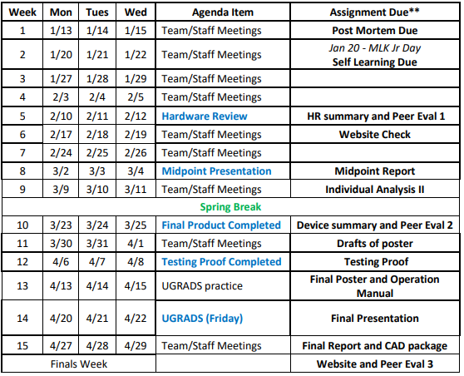
Based on the above, pulled from BBLearn, a tentative work schedule for next semester has been created.

Table 5: 486C Work Schedule
Operations | Start Date | End Date | Description
Frame Modifications | 1/14 | 2/4 | Frame alterations that are required to fit the electrical components.
Suspension parts fabrication | 1/14 | 2/11 | Fabrication of replacement suspension components. Priority: Front knuckle spindles, rear knuckles
Mounts | 1/21 | 2/4 | Installation of steering system.
Motor, Motor Controller, and battery installed | 2/4 | 2/11 | Installation of Motor MC, battery, and ancillary electrical system
Steering System Installed | 2/11 | 2/18 | Installation of steering system
Braking system Installed | 2/18 | 2/25 | Installation of braking system
Testing | 2/25 | 4/8 | Testing and evaluation of the vehicle and its subsystems

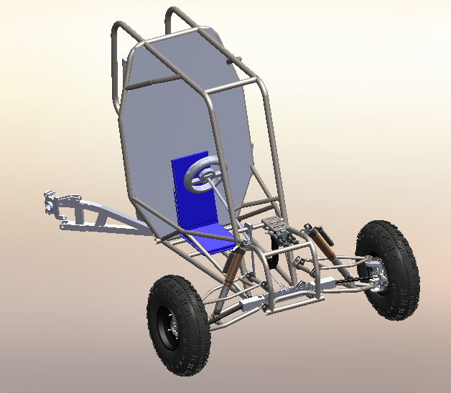
Figure 11: Assembly view of vehicle
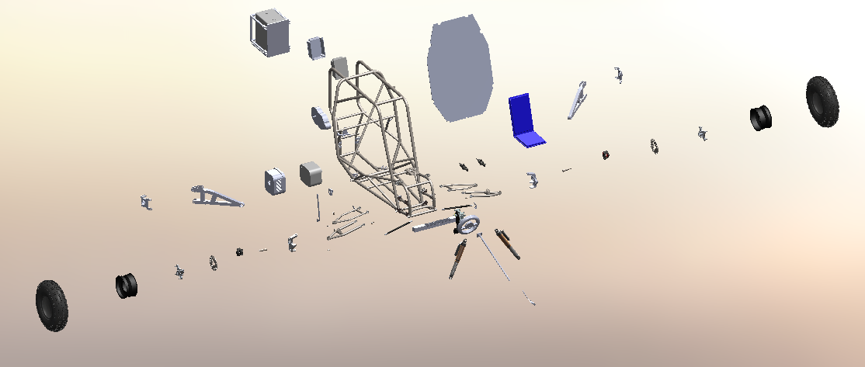
Figure 12 - Exploded view of Vehicle

Currently only a small amount of the starting budget has been utilized for the purpose of the procurement of new parts and fasteners, around $300, which leaves most of the $3000 initial budget remaining for the implementation of the design. The current bill of materials/bill of materials is available in Appendix A for a detailed look at last semester's costs and the exact amount of the budget that is remaining.

CONCLUSIONS
This report documents the work completed by the mechanical engineering sub team of the eBaja capstone project in the Fall 2021 semester, as well as a tentative schedule proposed for the Spring 2022 semester. From the project description, the tasks for this project include mechanically restoring a rolling chassis and replacing the original internal combustion engine components with electrical drivetrain components. Combining efforts with an electrical engineering sub team and their advisor, Dr. Venkata Yaramasu, the final design for this project will run entirely off electric power.
From competition manuals and a preliminary advisor meeting, the team was able to compile customer needs and generate corresponding engineering requirements. These requirements were used in a House of Quality analysis, which provides insight into the most important customer needs and engineering requirements. Preliminary design space studies were conducted via literature reviews for each of the team’s subsystems, allowing for insight into popular design decisions and considerations for the respective subsystems. A functional decomposition was generated by the team using a Black Box model and a functional model of the proposed design, which highlight crucial operational procedures for the vehicle. Concept generation and selection for the teams’ designs involved using a Pugh chart and decision matrix, where the top designs were analyzed on their ability to best fulfill the engineering requirements listed in the House of Quality; calculations are provided as justification for design decisions. Throughout these tasks, the team has been meeting every week in the Machine Shop at NAU to progress in the restoration of the vehicle.
The final solution of the design for this semester has been shown previously in the executive summary of the report. In detail, the team has decided to use the previous components designed by the original SAE Baja team to restore the vehicle to a rolling chassis. The CAD model shown depicts the progress made throughout the semester. The prototype is missing all four tires and the steering and braking subsystems. It is desired to have the suspension system fully restored before the end of the semester, ready to have wheels implemented by or before the next semester. Next semester’s main task will be to fully restore all mechanical subsystems and mount the electrical drivetrain components. After this, testing and redesign processes can begin, which will lead to the completion of this project.

REFERENCES
[1] “Baja saeindia rulebook 2021.” [Online]. Available: https://bajasaeindia.org/pdf/BAJA-SAEINDIA-RULEBOOK-2021.pdf. [Accessed: 21-Nov-2021].
[2] “Fundamental rating factors and calculation methods for involute spur and helical gear teeth.” [Online]. Available: https://wp.kntu.ac.ir/asgari/AGMA%202001-D04.pdf. [Accessed: 21-Nov-2021].
[3] “Codes & Standards,” ASME. [Online]. Available: https://www.asme.org/codes-standards. [Accessed: 21-Nov-2021].
[4] List of welding codes - american welding society (AWS) standards. [Online]. Available: https://www.liquisearch.com/list_of_welding_codes/american_welding_society_aws_standards. [Accessed: 20-Nov-2021].
[5] “IFI,” Free Technical Information | Industrial Fasteners Institute. [Online]. Available: https://www.indfast.org/info/free-technical-info.asp. [Accessed: 20-Nov-2021].
[6] “ANSI ABMA-9-2015 - American Bearing Manufacturers Association.” [Online]. Available: https://www.americanbearings.org/store/viewproduct.aspx?ID=16220325. [Accessed: 20-Nov-2021].
[7] V. Bhatt, G Nakhat, “IJERT-Braking Calculation for a BAJA ATV.” International Journal of Engineering Research and Technology, Vol. 10 Issue 04, April-2021. Accessed on: November 21,2021[Online] Available: https://www.academia.edu/46961044/IJERT_Braking_Calculation_for_a_BAJA_ATV

APPENDICES

Appendix A: House of Quality
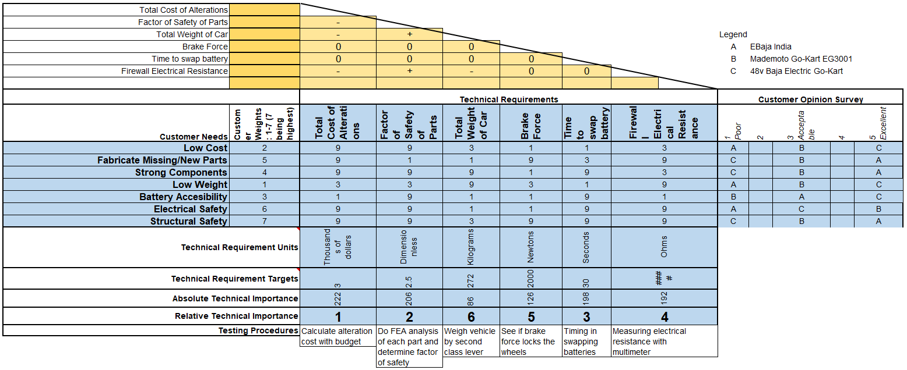
Figure 13: House of Quality

Appendix B: Gearbox Calculations
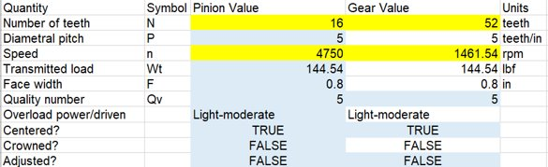
Figure 14: Number of Teeth of First Set of Gears

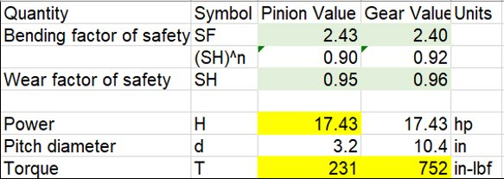
Figure 15: Output Torque and Factors of Safety

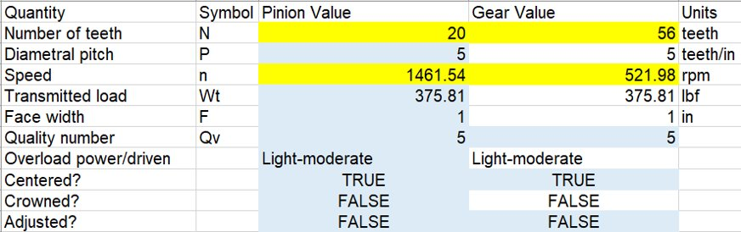
Figure 16: Number of Teeth for Second Set of Gears

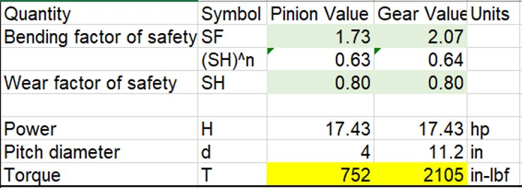
Figure 17: Output Torque and Factors of Safety

Appendix C: Braking System Calculations
Figure 18: Braking System Calculations

Appendix D: Bill of Materials
Figure 19: Bill of Materials

